# Milton Francisco December 12, 2024

# CS 255 System Design Document

## UML Diagrams

### UML Use Case Diagram

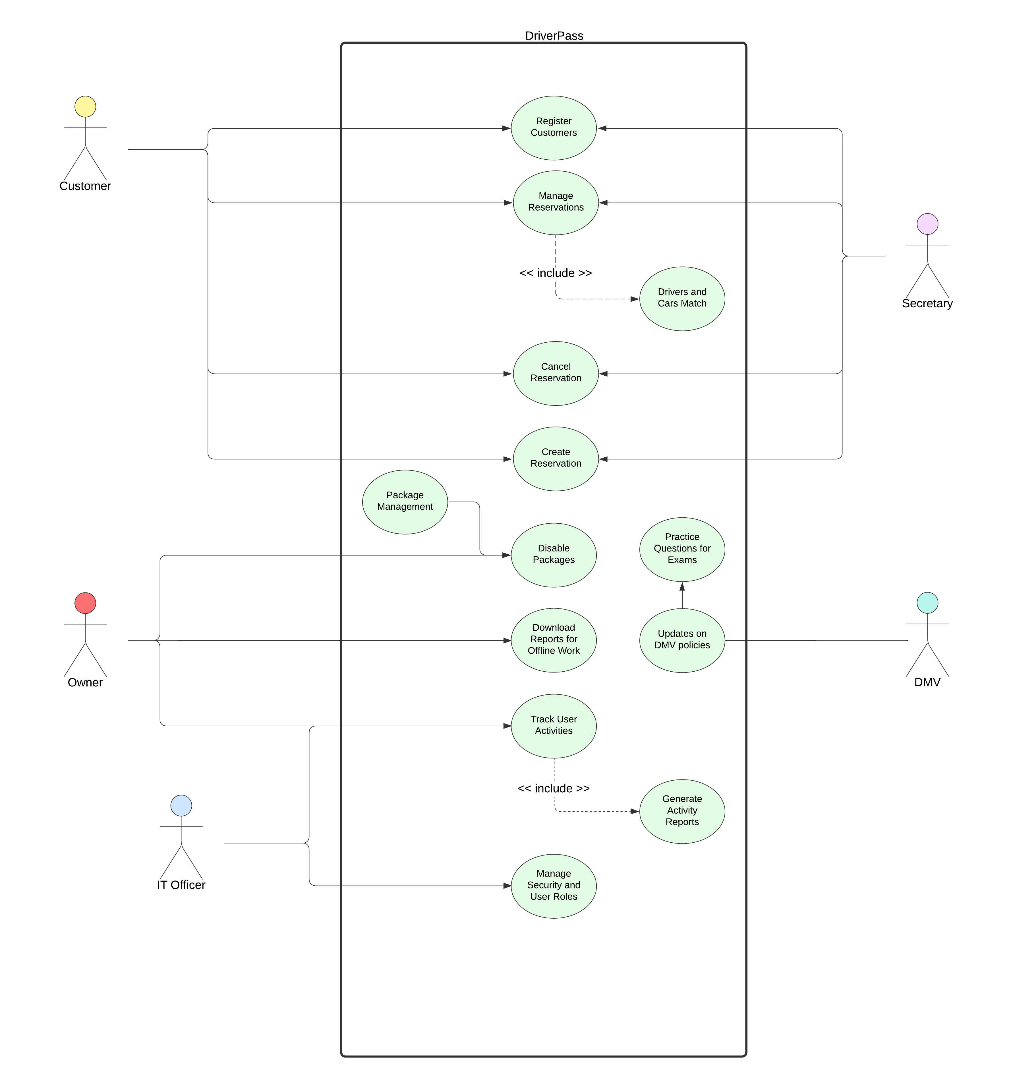

### UML Activity Diagrams

### UML Sequence Diagram

### UML Class Diagram

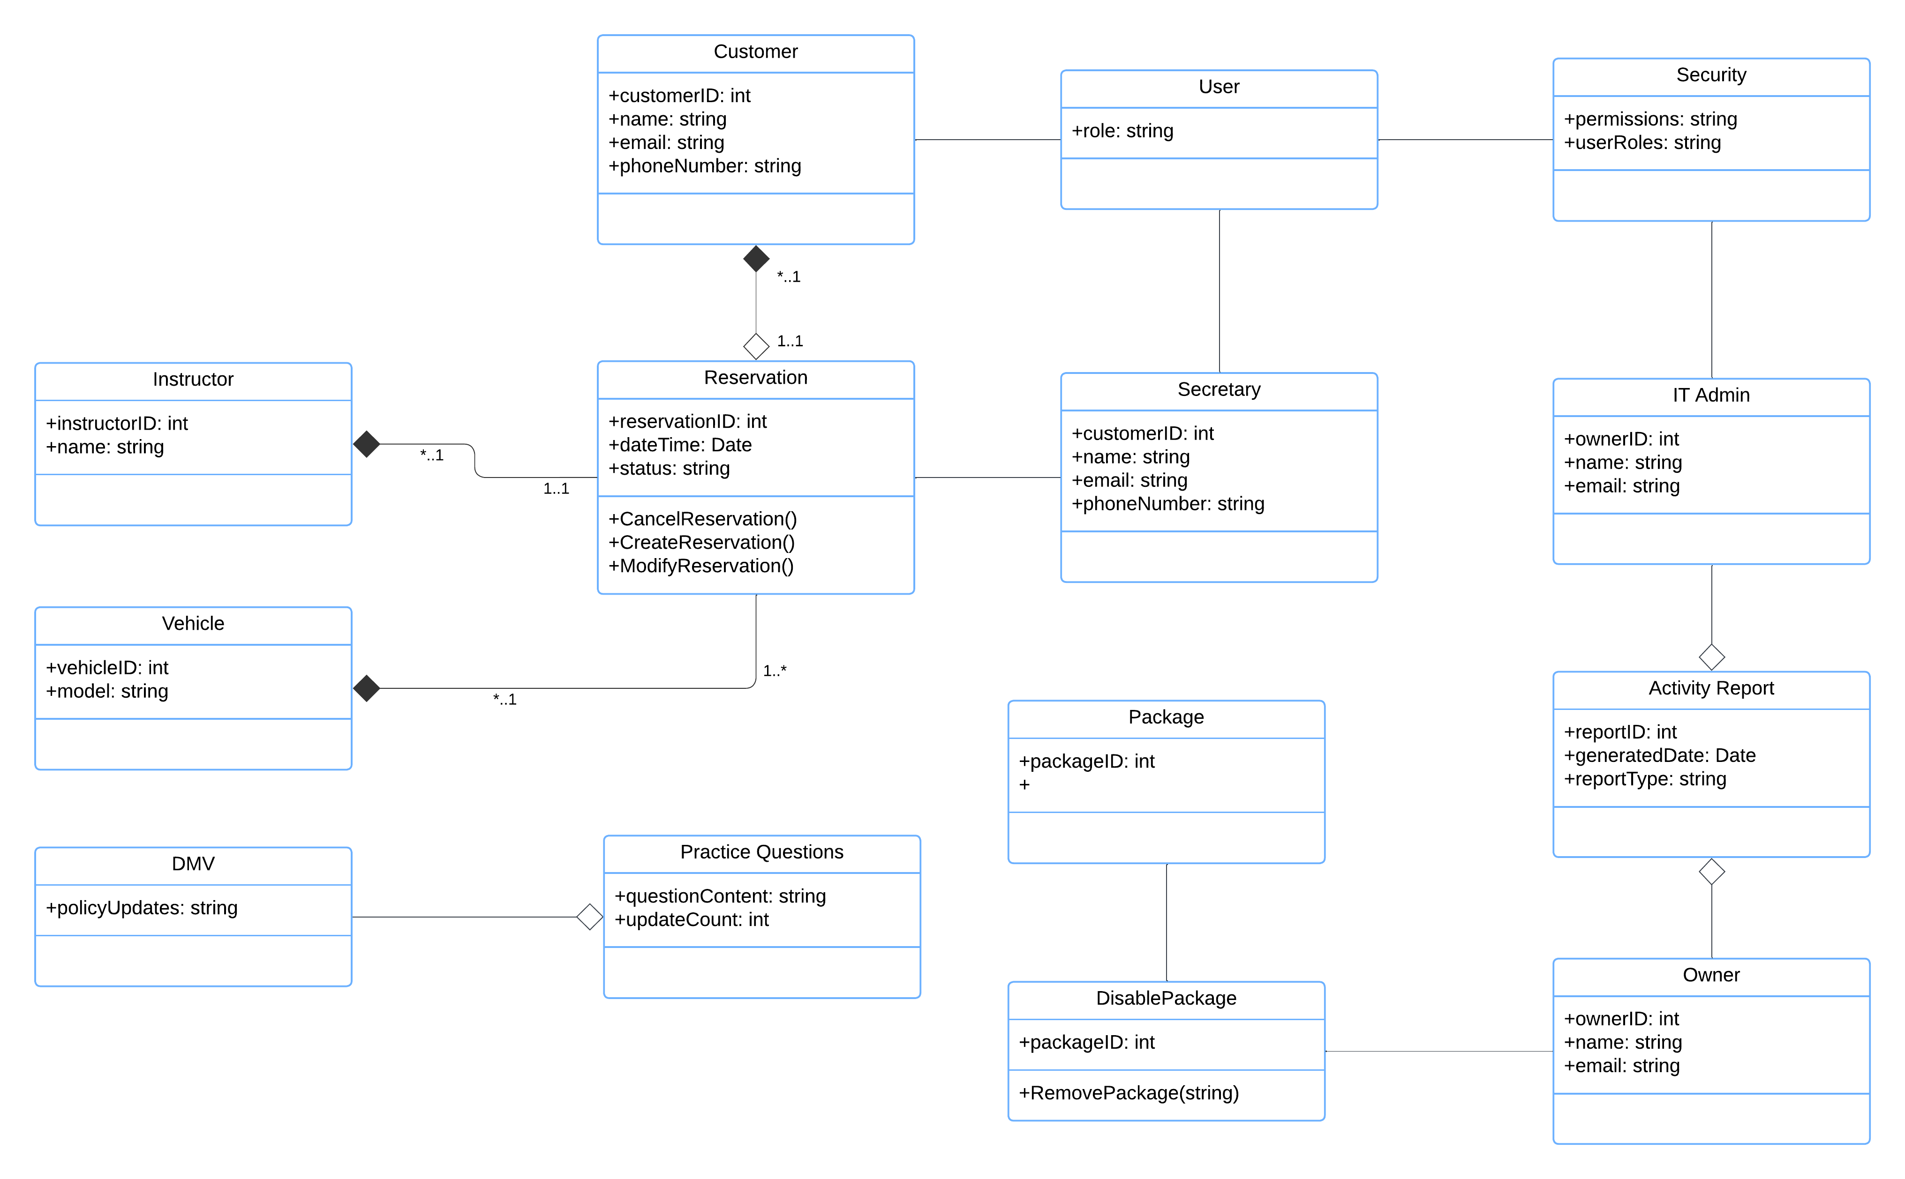

## Technical Requirements

Based on the functional and nonfunctional requirements outlined in Project One, the following technical requirements have been determined.

Since this will be a cloud-based system, the mid-range offerings offer 16GB of RAM, 8 CPU cores, 320GB of storage, and 6TB bandwidth. This usually costs around $100/month depending on the provider. This is ideal because as your business grows, you can add additional resources where they are needed.

The software requirements should use C# for the server-side language, the .NET framework and MS SQL Server for the structured data storage. Utilizing Microsoft Azure could provide additional storage and DevOps functionality, such as Continuous Integration/Continuous Delivery tools. The front-end should use HTML, CSS, and JavaScript/TypeScript. This can allow the use of frameworks such as Angular or React to aid in building responsive and dynamic interfaces. Additionally, this could aid in cross-platform reliability.

The tools needed for this will include personal computers, as well as an IDE, such as Visual Studio for backend, and Visual Studio Code for frontend. Additionally, Git will allow ideal code management and Postman can aid in testing.

The infrastructure was alluded to earlier, but the cloud platform can be AWS, or even Azure as a host. These will use virtual machines to host the application. Additionally, they can provide load balancing and security measures for secure access. Overall, this will allow your application to be highly scalable, highly available, and ensure there is room for growth as your company expands.